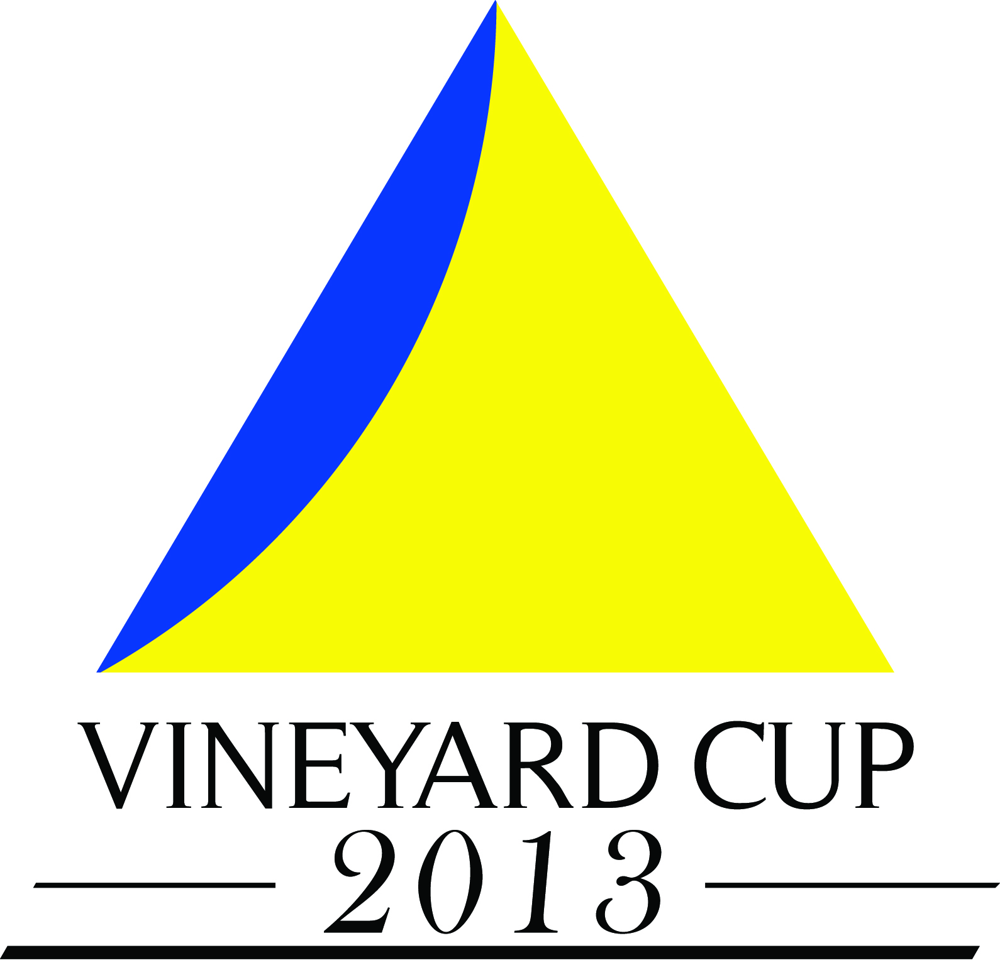


SAILING INSTRUCTIONS

- RULES:
  - The Vineyard Cup will be under the jurisdiction of Sail Martha’s Vineyard and shall be governed by:
    - The Racing Rules of Sailing 2013 - 2016 (the “Rules”);
    - The PHRF NE Rules;
    - Any modifications thereto by these Sailing Instructions; and
    - These Sailing Instructions

- NOTICES TO COMPETITORS:
  - All notices to competitors will be posted on the Official Notice Board located at Race Headquarters at 110 Main Street, Vineyard Haven. The Race Committee will attempt to post copies of all such notices on the courtesy board in the Race Village at the base of Beach Road Extension, any conflicts will be resolved by the Official Notice Board.

- CHANGES IN SAILING INSTRUCTIONS:
  - Any changes to these Sailing Instructions will be posted on the Official Notice Board not less than two hours prior to a Division’s first warning signal on the day the change is to take effect except that any change to the schedule of races will be posted by 2000 hrs on the day before it will take effect.

- SIGNALS MADE ASHORE:
  - Signals made ashore will be displayed from the Black Dog Wharf flagpole. If a postponement is signaled ashore, the warning signal will be made not less than one hour after the AP is lowered.

- SCHEDULE:
  - Friday, July 12, 2013 WRI Weather briefing at 1030 hrs at Race Headquarters.
  - Friday, July 12, 2013 Competitors Meeting at 1100 hrs at Race Headquarters.
  - Friday, July 12, 2013 First warning signal at 1300 hrs.
  - Saturday, July 13, 2013 The starting sequence for Classes 4, 1, 2, and 3 will begin at 1005 hrs.
  - Sunday, July 14, 2013 Pursuit Format: Warning signal for first boat
at 1030 hrs.

- CLASSES:
6.1. Boats will be divided into the following Classes and designated by the numeral pennant indicated:

    - CLASS 1 – PHRF Non-Spinnaker



    - CLASS 2 – PHRF Non-Spinnaker



    - CLASS 3 – PHRF Spinnaker



    - CLASS 4 – Classic

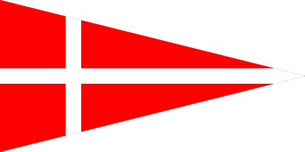

  - The decision as to what Class a boat races under rests solely with the Race Committee.

- STARTING AREA:
7.1. The starting and finishing lines will be positioned approximately ¼ nm (at a bearing of 65° M) from Fl G “7” at the end of the Eastville jetty.

- RACING AREA:
8.1. The racing area will be in Vineyard Sound, Buzzards Bay and Nantucket Sound.

- MARKS:
9.1. All marks shall be government marks with the following exceptions:
- The Committee Boat;
- The pin end of the starting and finishing lines which will be a rigid bottom inflatable displaying an orange flag; and
- The Cow Bay turning mark (Skiff #1) for courses 3 and 4 is a 12’ white flatiron skiff with a 4’ x 4’ orange flag flying from its mast.

- COURSES:
COURSE #1 L’HOMMEDIEU SHOAL COURSE (approximately 10.9 nm)
Start to N”4” (leave to port) to C”25” (leave to port) to R”26” (leave to starboard) to C”15” at the western end of L’Hommedieu Shoal (leave to starboard) to RG N at the west end of Hedge Fence (leave to starboard) to Finish.

COURSE #2 RACE TO THE ROCK…AND BACK (approximately 29.1 nm)
Start to N “4” (leave to port) to C”25” (leave to port) to GR Lone Rock at the north entrance to Quicks Hole (leave to starboard) to C”25” (leave to starboard) to N “4” (leave to starboard) to Finish. Skippers may approach and return from Lone Rock by any course they choose. Passage through Wood’s, Robinson’s or Quick’s Holes in either direction is permitted. Extreme caution, good seamanship and sound judgment are strongly recommended when determining a vessel’s course and passage.

COURSE #3 CAPE POGE COURSE (approximately 16.9 nm)
Start to C”23A” (leave to starboard) to GR east of the Oak Bluffs ferry pier (leave to starboard) to C”1” Lone Rock off Oak Bluffs (leave to starboard) to Skiff #1 approximate position of 41° 25’ 35” N by 70° 32’ 30” W (leave to port) to R”2” (leave to starboard) to G”21A” approximately 2.1 nm northeast of Cape Poge (leave to port) to RG N at the west end of Hedge Fence (leave to port) to Finish.

COURSE # 4 COW BAY COURSE (approximately 11.1 nm)
Start to C”23A” (leave to starboard) to GR east of the Oak Bluffs ferry pier (leave to starboard) to C”1” (leave to starboard) to Skiff #1 approximate position of 41° 25’ 35” N by 70° 32’ 30” W (leave to port) to R”2” off of Edgartown (leave to port) to Finish.

COURSE #5 HEDGE FENCE COURSE (approximately 10.5 nm)
Start to C “23” (leave to starboard) to R “22” (leave to starboard) to GR Bell (leave to starboard) to G “23” (leave to port) to Finish.

Course # 6 LUCAS SHOAL COURSE (approximately 21.3 nm)
Start to R “2” (leave to port) to C “25” (leave to port) to G “27 (leave to port) to GR C “LS” at Lucas Shoal (leave to port) to C”25” (leave to starboard) to R “2” (leave to starboard) to Finish.

NOTES:
- The course for each Class will be designated by the appropriate number displayed on a white board on the starboard side of the Committee Boat. If a course designation is followed by “R”, the course is to be sailed in the opposite order as described above and marks are to be left on the opposite side.
- ALL BOATS SHOULD TREAT N”4” AND C”23A” AS A GATE AND SHALL PASS BETWEEN THEM OUTBOUND FROM THE START LINE AND INBOUND TO THE FINISH LINE. THERE ARE NO EXCEPTIONS TO THIS REQUIREMENT.
- The start and finish lines will be positioned approximately ¼ nm (at a bearing of 65° M) from Fl G “7” at the end of the Eastville jetty.
- Skiff #1 is used as a mark in Courses #3 and #4 will be a 12’ white Flatiron Skiff and will fly a 4’ x 4’ orange flag from its mast.

- THE START:
  - Races will be started by using the Rule 26 format with the warning signal given ten minutes before the starting signal and the preparatory signal given five minutes before the start.
  - The starting line shall be between an orange flag on the Race Committee Boat at the starboard end of the starting line and an orange flag on the Pin Boat at the port end of the starting line.
  - On Friday and Saturday, July 12th and July 13th starts will be rolling, meaning the start for a preceding Class is the warning signal for the next Class. On Sunday, July 14th a Pursuit format will be used with each boat being assigned a specific starting time. Those starting times will be posted on www.vineyardcup.com, on the Official Notice Board at the Race Headquarters and at the Race Village by 1800 hrs, Saturday, July 13th.
  - The sequence of starts on Friday, July 12th will be: Class 1, Class 2, Class 3 and on Saturday, July 13th Class 4, Class 1, Class 2, Class 3.
  - Boats whose Class warning signal has not been made shall remain well clear of the starting area.
  - The Race Committee may deploy a small orange inflatable spherical buoy at a distance of eight to ten feet from the transom of the Committee and or Pin Boat(s), the purpose of which will be to keep starting boats well clear of the Committee and or Pin Boat(s). Such buoy and its painter, if deployed, will be deemed to be an extension of the Race Committee and Pin Boat(s).

- CHANGING THE COURSE AFTER THE START:
12.1. A change of course after the start will be signaled at the rounding mark before the leading boat has begun the new leg.

- THE FINISH:
13.1. The finishing line shall be between an orange flag on the Race Committee Boat at the port end of the finish line and an orange flag on the Pin Boat at the starboard end of the finish line.

14. TIME LIMIT:
14.1. The time limit for the first boat to finish in each Class on Friday, July 12th will be three hours.
14.2. The time limit for the first boat to finish in Classes 1, 2, 3 and 4 on Saturday, July 13th will be four hours.
14.3. On Friday, July 12th and Saturday, July 13th a boat failing to finish within two hours of the first to finish in its Class will be scored DNF without a hearing. This changes Rules 35, A4 and A5
14.4. On Sunday, July 14th each boat must complete the course by 1530 hrs or will be scored DNF without a hearing. This changes Rules 35, A4 and A5.

15. PROTESTS:
15.1. A boat intending to lodge a protest shall comply with all provisions of Rule 61 and shall notify the Race Committee immediately upon finishing of that intent, providing to the Race Committee the name, sail number (if shown on the sail) and Class of the boat being protested.
15.2. Protests shall be filed in writing with the Protest Committee at Race Headquarters on forms available from the Race Committee desk within one hour of the last boat to finish the last race of the day in her Class, such time to be posted on the Race Committee Bulletin Board at Race Headquarters.
15.3. The Jury will hear each protest in the order posted, beginning as soon as possible after the completion of the day’s races.

16. PENALTY SYSTEM:
16.1 Rule 44.3(c) will apply. The scoring penalty will be 20% of the number of boats in that Division that start the race.

17. SCORING:
17.1. One race is required to be completed to constitute a series.
17.2. Boats will be scored using PHRF-NE ratings or in the case of the Classic Division using a locally assigned PHRF ToD based system.
17.3. There will be no throw-outs.

18. SAFETY:
18.1. Each day, every yacht shall check in with the Race Committee at the starting area by passing astern of the Race Committee Boat on starboard tack, stating the boat’s name, class and sail number. The Race Committee will acknowledge by responding with the boat’s name. Check-ins will not be accepted via VHF.
18.2. Any yacht withdrawing from a race SHALL report her withdrawal to the Race Committee on VHF Channel 72 and by calling 508.627.0509 as soon as practicable after her decision to abandon the race.
18.3. Sail Martha’s Vineyard strongly advises all crews to wear PFD’s at all times.

19. DISCLAIMER OF LIABILITY:
Each owner, skipper and individual participating crewmember (“Person”) agrees to be bound by the Rules. Furthermore, each Person agrees that the sole responsibility for the seaworthiness of the boat, her rigging, the safety equipment on board, the wearing of PFD’s and the competence and behavior of her crew is that of the Owner/Charterer/Skipper of the boat.

Each Person participates in the regatta entirely at their own risk and represents that he/she is acquainted with RRS Rule 4 which states, “The responsibility for a boat’s decision to participate in a race or to continue racing is hers alone.” Sail Martha’s Vineyard will not accept any liability for material damage or personal injury or death sustained in conjunction with or prior to, during, or after the regatta.

Each participant also agrees to relieve from any responsibility or liability Sail Martha’s Vineyard, its Directors, employees, volunteers, members, agents and sponsors and their representatives in respect of any claim arising from participation in the Vineyard Cup, to include loss of life, injury or loss of or damage to any vessel or property.

20. MEDIA RELEASE:
Competitors and crewmembers on competing boats grant, at no cost, Sail Martha’s Vineyard the absolute right and permission to use their name, voice, image, likeness, biographical material; as well as representations of the boats in any media (including but not limited to television, print and internet media), including video footage, for the sole purpose of advertising, promoting and disseminating information regarding the Vineyard Cup and Sail Martha’s Vineyard and its programs.

